Sites to See: Boissevain - Morton

Visitors who want to see more and know more about the Boissevain area should take note of the Vantage Points Local History Resources Binder, and the inventory of “Special Places”

William Lake & Turtle’s Back

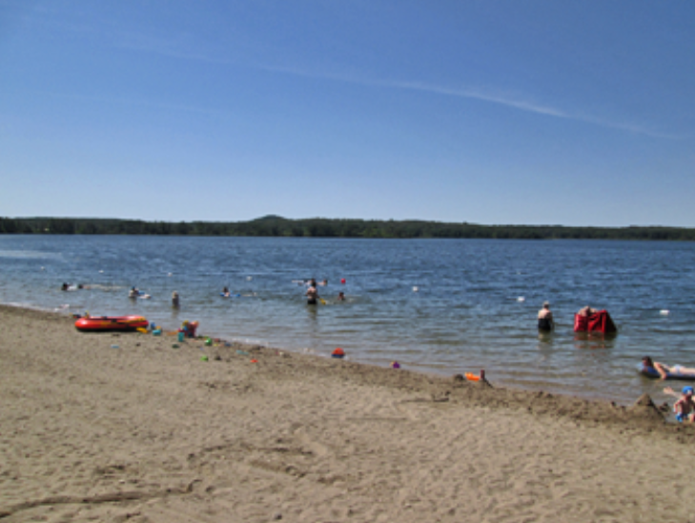

Travelling west towards Boissevain on Highway 3, offers a view to the south of the eastern ridge of Turtle Mountain. The high point, known as Turtle’s Back is often visible. Turn down William Lake Road to get a closer look, and experience the terrain. The roads ends at the lake, and an access to the Turtle’s Back Trail, which takes you to an even more inspiring view of the countryside in all directions.

Max Lake

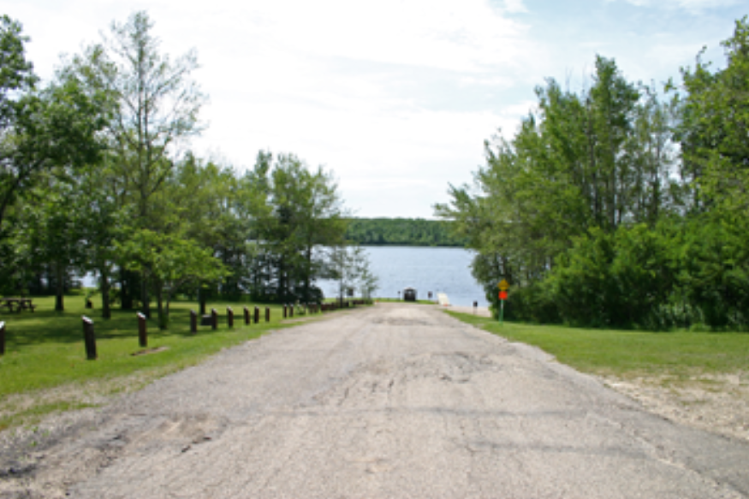

Max Lake was the recreation hot spot in pioneer days as well as the site of an important sawmill. Take a trip down Max Lake Road, off of Highway 3, west of Boissevain to get a good look at the heart of Turtle Mountain.

Horton / Desford / Boundary Trail

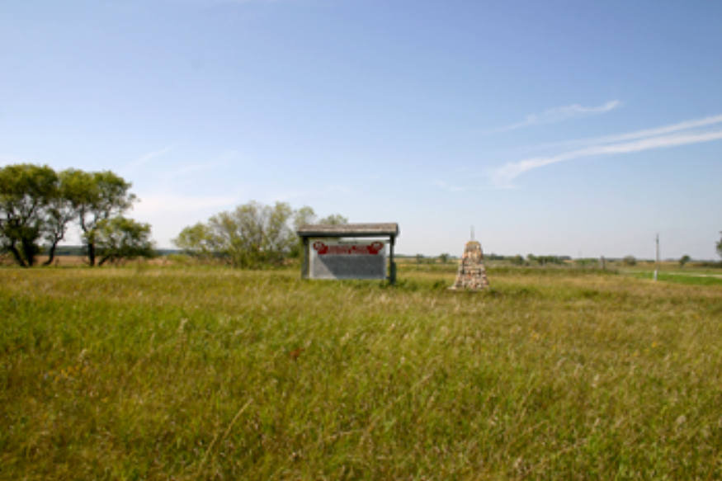

South on Highway 10 you will find a sign identifying the Boundary Commission Trail and commemorating the Desford and Horton Settlements.

International Peace Garden

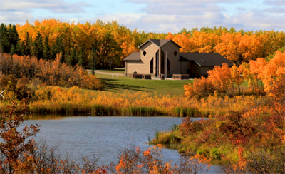

For 86 years the Peace Garden has been a symbol of peace and cooperation and a jewel on the prairie. The vision of a few men to create a special place and the 50,000 who gathered for its dedication in

