

Historic Resources Branch Report

**Old Mill Office**

## Block 13, Plan A, Lots 13-15

Rapid City, Manitoba

(430.D.1)

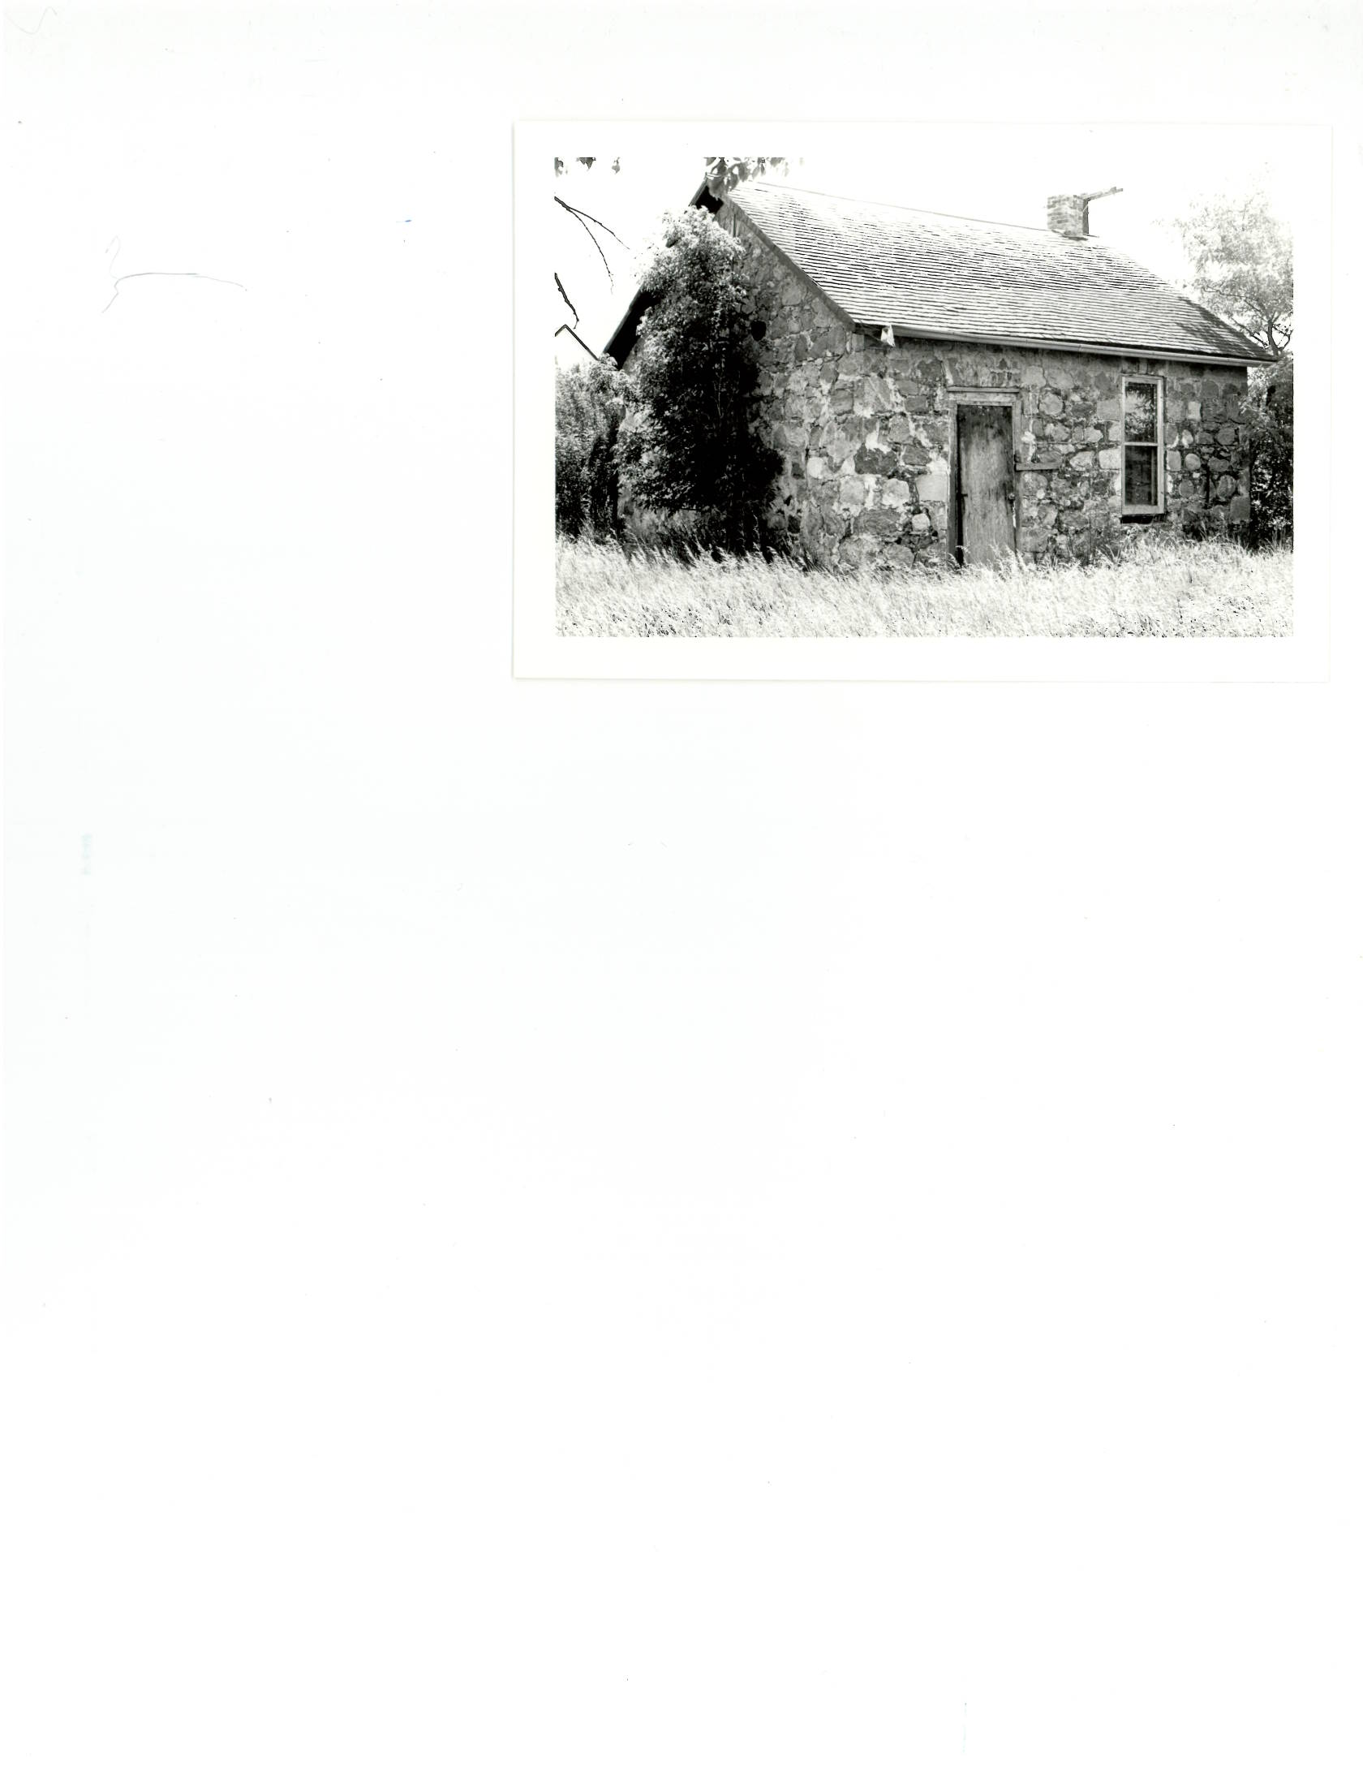

**Neil R. Bingham**

Historic Resources Branch

July 1978



The Old Mill Office in Rapid City, Manitoba, is only a one-room structure, measuring approximately 20’ x 21’. Considering its small size, it is interesting to consider the building's relatively long occupancy by such diverse owners. Originally built and used as the office for the McCulloch & Co. grist mill, the mill it served has long since been demolished. Opening in 1880, the mill was owned by George McCulloch. With power provided by the rapids of the river, this was the first substantial mill to be built in Rapid City. Grain from a fifty-mile radius was ground and processed within three large two and four-storey buildings that housed the company operations. With the coming of the railroad to Rapid City in 1887, McCulloch’s milling operations soon increased. In 1909, the mill was sold and the name changed to the Rapid City Milling Company. Within the next decade the property changed ownership three times. Apparently, operations were successful with orders of flour being shipped to such distant ports as Glasgow, Scotland. However, economic pressures closed the mill about the time of the end of World War I. The buildings were either demolished or moved out of town early in 1919.[1]

But the mill office remained. The date of erection is not recorded, but it is most likely that the office building was constructed at the same time as the first mill buildings, around 1880. Located at the west end of the town’s main street, the office was no doubt the centre of the book-keeping and accounting for the mill. After the mill closed, the property either reverted to or was bought by the Town of Rapid City in whose hands it remained until 1930. It was then purchased by William Eastgate, who probably converted its use to a residence.[2] In 1946, a retired farmer, Syras Terry, bought the building. From 1950 to 1956, Remmert Radsmer occupied the old office until its last owner, Andrew Wright, moved in.

Mr. Wright was a local resident who hired himself out as a farm labourer. He lived in the one-room structure until his death in 1969. The building has been vacant since then. After a lengthy period of transactions, the mill office is now in the hands of the Rapid City Museum.

Structurally, the building is quite simple. Almost square in plan, the walls are made of local fieldstone. The walls are more than several feet thick thus placing the windows within deep recesses. The extreme thickness of the walls leads one to believe that it is of cavity wall construction; really two walls with a space between. The door on the north side originally was protected by an enclosed wooden entrance porch.[3] There is a trap door near the east wall which leads to a small cellar.

The roof, constructed of wood rafters, has been badly damaged in patches. Also several cracks appear in the wall. Basically, however, the Old Mill Office is quite sound, a result of the solid materials and construction methods employed.

**Endnotes**

1. For a concise history of milling operations in Rapid City see Tully McKenzie, *It’s Time to Remember*. Brandon: the Author, c. 1975, pp. 168-170.
2. Block 13, Plan A, Lots 13, 14 and 15. Town of Rapid City Assessment Records, 1922-1970.
3. The only known accessible photograph of the building when it was the mill office was published in the *Illustrated Souvenir of Rapid City, Manitoba,* Brandon: W.A. Martel & Son, c. 1902-03. Two mill employees are pictured standing in front of the enclosed porch.